Marketing for Apartment Rental Replacement using Data Science

# Introduction

When my husband and I signed the 12-month lease and moved into a beautiful newly renovated apartment in a tranquil neighborhood at Northside Houston, none of us would expect our decision to move out a few months into the lease before the lease ends. After attempts to negotiate with the leasing office by offering win-win solutions, we decided that the best way to get out of the lease is to find someone to take over my lease. The process of finding a replacement tenant was more difficult than I thought. I started the process by hiring a real estate agent. Two months later, the agent returned the apartment keys and relieved himself from this responsibility, leaving me on my own on this challenging task.

In order to better market my apartment and reach the advertisement to more people, I used Python to collect and analyze all communication history with people inquiring about the apartment. Through this data analysis, I was able to find the *most effective platform for marketing*, *the likelihood of interested people in viewing the apartment, people’s inquiries’ fluctuation with date, weekday, and time of the day, and the keywords associated with people end up visiting and not end up visiting*. Understanding this information helped me *post and renew my listings at the right time with the right platform, know when to expect large amount of inquiries, and draft an advertisement that will attract the right kind of people*.

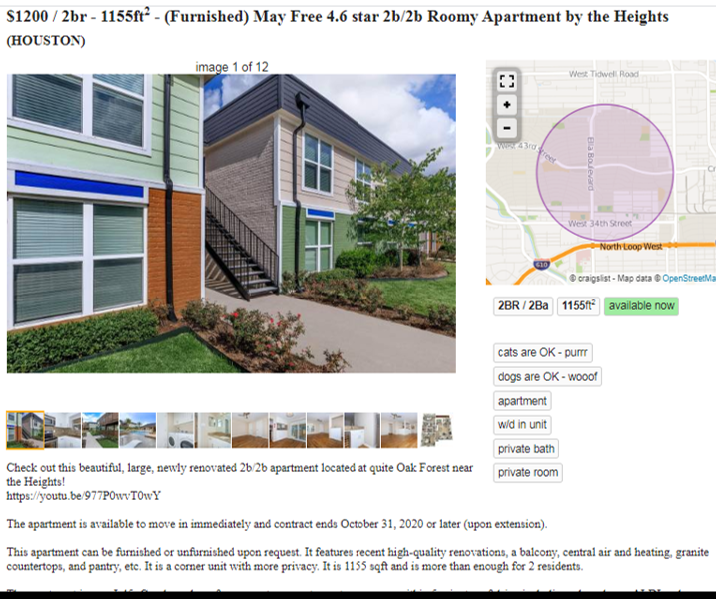

Image 1: a screenshot of my apartment advertisement on Craigslist.

# Methodology

The process is as follows:

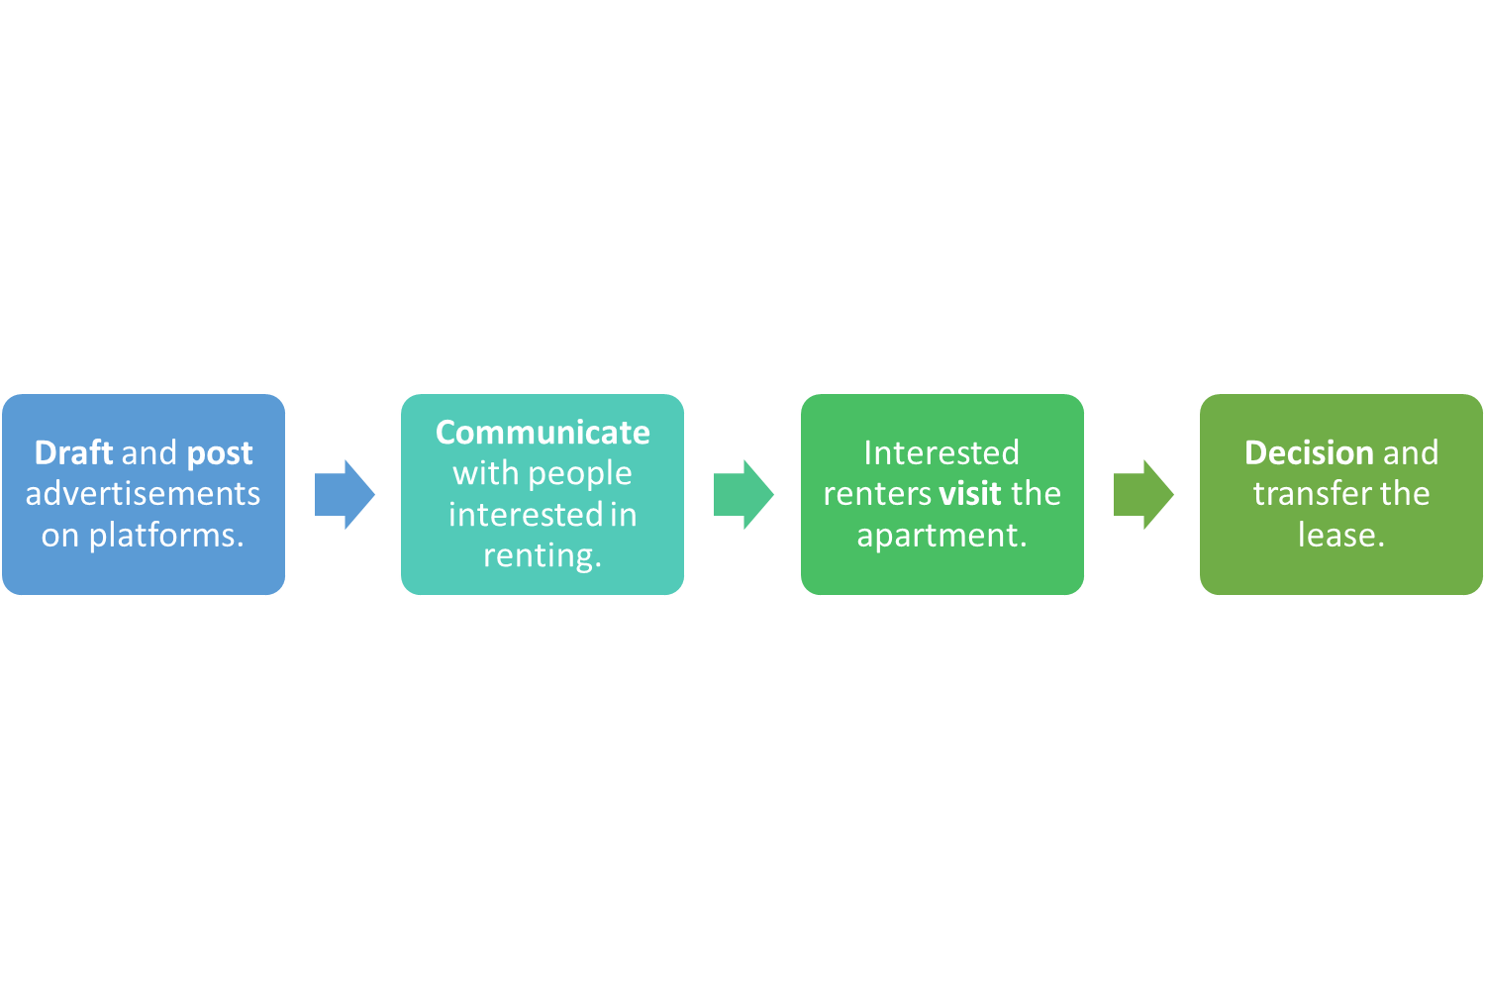

First, I draft and post the advertisements on advertising platforms. Then I will wait until interested parties contact me about the advertisement. Some people will end up visiting the apartment after initial communication. My success comes when one of them find everything satisfying and sign the lease.

Most of the inquiries I got were from advertisements on four websites: Craigslist, Facebook Marketplace, Nextdoor.com, and sublet.com. I extracted all the raw inquiry data from the sources in different formats:

* Craigslist: email and text message
  + Format: mbox for email, excel for text messages
* Nextdoor: Nextdoor inbox
  + Format: excel
* Facebook: Facebook messages
  + Format: JSON file for each conversation
* sublet.com: sublet.com inbox
  + Format: excel

And then concatenate all the data together into one master DataFrame for further analysis.

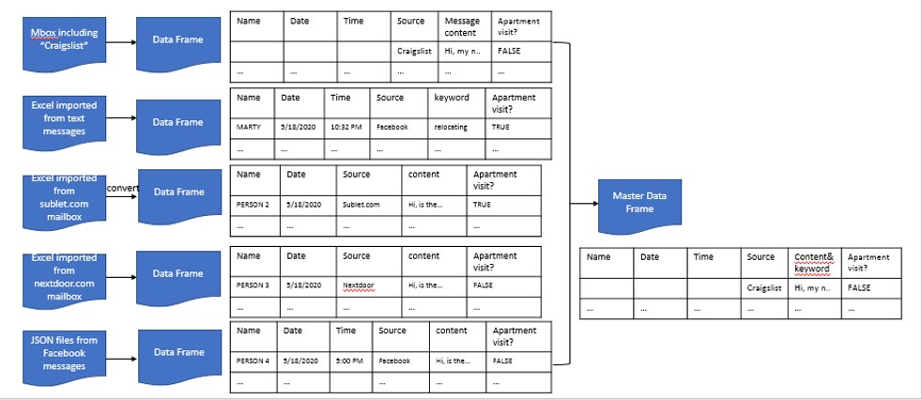

For email communications from Craigslist, I first filtered all emails in my Gmail inbox containing keyword “Craigslist” and downloaded all the emails in one mbox file. The mbox file was read in Python using the mailbox package. The Name of senders, the date and time of the communications, as well as the content of each message was extracted from the mbox file and put in a pandas DataFrame. The Datetime of each message was further parsed into different columns of “Date”, “Weekday”, and “Time”. In the end, I have a clean DataFrame with columns “Name”, “Weekday”, “Date”, “Time”, “Source”, “Content”, and “Visit”. The first 5 rows of the chart is shown below:   
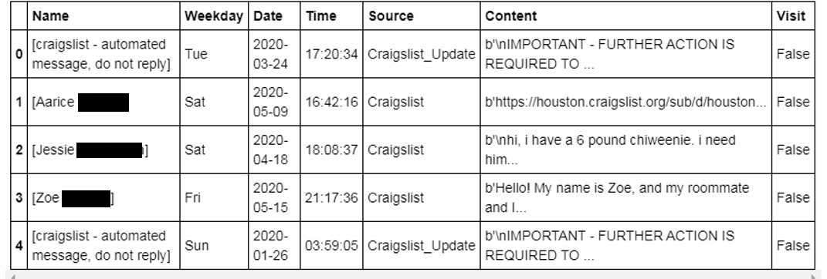

Table 1: extracted information from emails.

Cheap as I am, I was unwilling to pay for an app that can automatically turn my text messages into an excel file. I manually input all information I need in the texts into an excel file and imported it into Python.

The message information from sublet.com and nextdoor.com were also manually input into an excel file respectively, and later on imported into Python into pandas data frames.

All Facebook messages were downloaded from Facebook.com. Communication with interested renters were in the messages section. All messages were provided as an individual JSON file. Actions relating to the advertisement post are in the Facebook posts section. The information relating to the post is in one JSON file.

I created a function that automatically reads all JSON files in my folder and extract entries I need from each file and put in a dataframe. This is very handy as I put all Facebook message JSON files in one folder. The timestamp of each messages in the JSON files are in a timestamp format as a long string of numbers. I used datetime and dateutil.parser package to read timestamp strings and turn them into date, time and weekdays.

The generated dataframe from facebook messages includes columns “Name”, “Content”, “Visit”, “Source”, “Date”, “Time”, and “Weekday”.

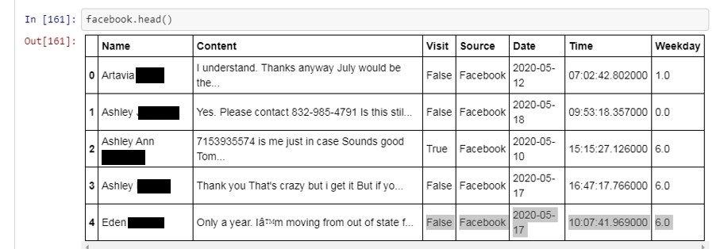

Table: the top 5 messages from Facebook inquiries.

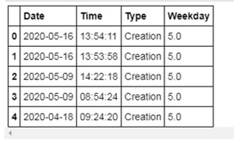

Table: all updates in my Facebook advertisement posts summarized in one table.

The concatenated DataFrame looks like following:

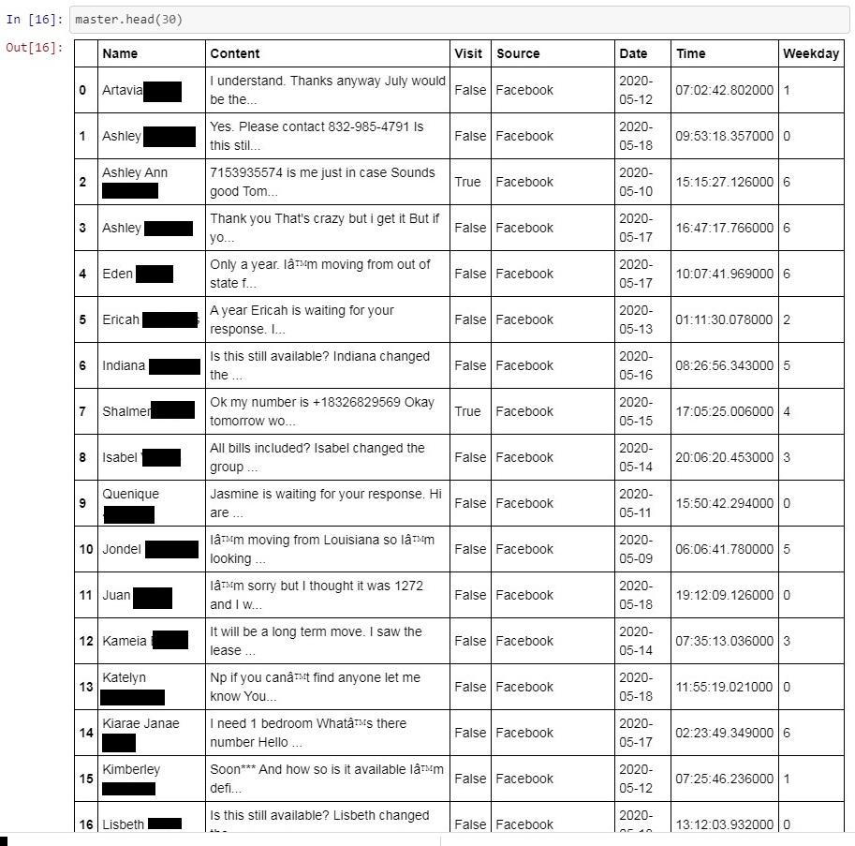

Table: The concatenated master DataFrame containing all advertisement information.

# Results and Discussions

## Numbers from the Cleaned and Summarized Table

A value count of the ‘Source’ values from the master data frame shows I got ***26*** interested people from *Facebook*, ***15*** from *Craigslist*, ***6*** from *sublet.com* and ***5*** from *nextdoor.com*, making a total of **52** inquiries. During the period, I have updated my Craigslist postings **8** times, created **5** Facebook posts and review one the posts **once**.

Counting the True and False numbers in the ‘Visit” column shows **8** out of **52** people ended up visiting.

## The outcome from Different Sources

A pie plot of number of inquiries from each of the four sources shows Facebook to be the most effective advertisement platform, as 50% of the inquiries I got were from Facebook.

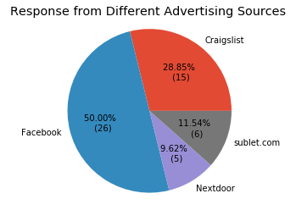

Image : Composition of interested renters from different resources.

Out of 52 people, 8 ended up visiting the apartment, counting 15% of total. This number gives me an idea on how many people I would expect visiting in the future.

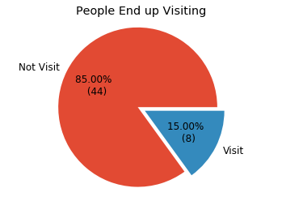

Another bar graph of people’s visiting rate from different advertisement platforms is calculated and plotted. The visiting rate is calculated as the number of people ended up visiting divided by total number of people asking about the apartment. It again shows Facebook to be the most promising platform, as 30% of interested people from Facebook ended up visiting.

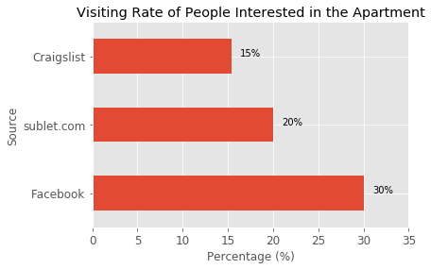

*In summary, Facebook is the most promising advertisement platform as it brings in the highest number of interested renters, and the renters are a better match to my apartment because the visiting rate is high. This leads to my decision in putting more effort into drafting the advertisement better, renew the posts more frequently, and even maybe invest money to bring attention with Facebook.*

## Inquiries with Time: People’s Inquiry Behaviors

Another trend I want to know is people’s inquiry behaviors as on which day and time they are more likely to contact me about the apartment. This will not only help me to prepare for potential inquiries at certain times to ensure promptness, but also deduct a good time to renew the post so more people can see it before the post gets buried by other newer posts.

First, I plot a bar graph of number of people inquiries with each day. The bars represent the number of people asking about the apartment. I annotated my advertisement administrative activities on the timeline as well.

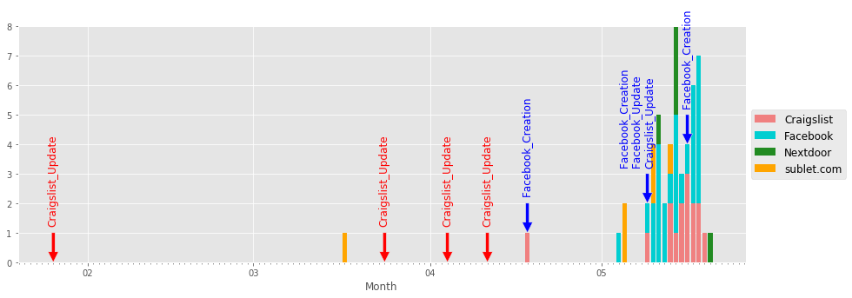

Image : the advertisement and inquiry activities for apartment advertisement

We can see from the graph that I started to advertise as early as in January but did not have anyone contacting me until the middle of March. My advertisement update activity increased after mid-March and started advertising on Facebook until mid-April. A huge influx of inquiries come in May.

Counting the number of inquiries by weekdays, we found that Monday gets the most inquiries. *Sunday is the second most popular day for inquiries. And then Thursday and Saturday. This is likely due to people browsing the advertisements over the weekend but did not contact until Monday. Thus the best date to renew the advertisement is Friday night or Saturday morning, right before the large influx of inquiries, as I make sure actively searching renters see my advertisement.*

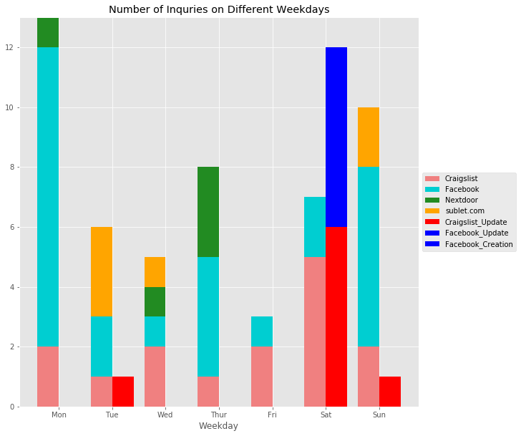

Image : the inquiry number by weekday.

The third time-dependent apartment inquiry behavior I looked at is the inquiry numbers by the time of the day. *Surprisingly, I got a significant number of inquiries from Facebook in the early morning between 1 am to 9 am. Most of the inquiries from craigslist are in the afternoon between 3 pm and 11 pm. In general, afternoon 3-5 pm is the most popular time for people to contact me. I should make sure to have my phone with me at that time to not delay a response.* *In terms of renewing the advertisement, if I follow the rule of renewing right before the influx of inquiry, then the best time to renew Facebook advertisements is around noon and to renew Craigslist advertisements is in the morning.*

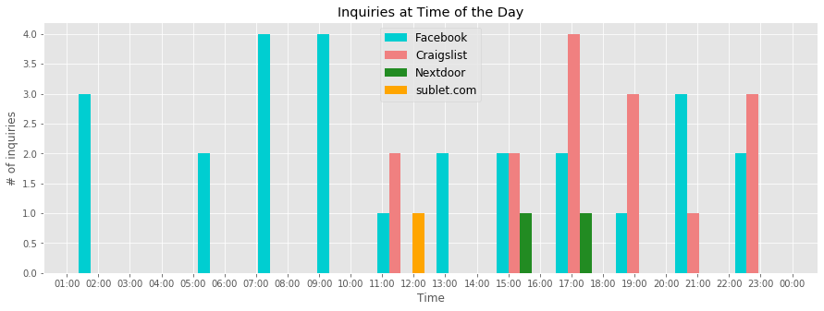

Image : number of inquiries at different times of day.

## People’s Interest through Keywords

I would like to better understand people’s interest from the content of the conversation. I divided the people contacting me into two groups: those ended up visiting the apartment and those did not. Extracting keywords from these two different groups first helps me optimize the content of my advertisement to target the right audience, it also help me predict if the person is likely to visit or not judging by the content of the conversation.

The keywords extracted from those visiting the apartment are as follows:

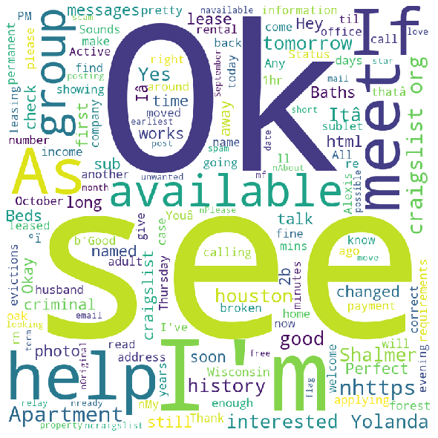

Image : word cloud generated from the conversation with people ended up visiting the apartment.

As we can see that most of the keywords are affirmative and brings a positive vibe including “OK”, “see”, “help”, “good”, “meet”, “perfect”, etc.

As for the conversation with those not ending up visiting the apartment, the keywords and more diverse. And there is also less affirmative words in the conversation. There are many keywords relating to the advertisement like “posting”, “ your AD”, “craigslist”, “post”, etc. Meaning the conversation mostly stopped after they ask about the advertisement, and not in too much depth.

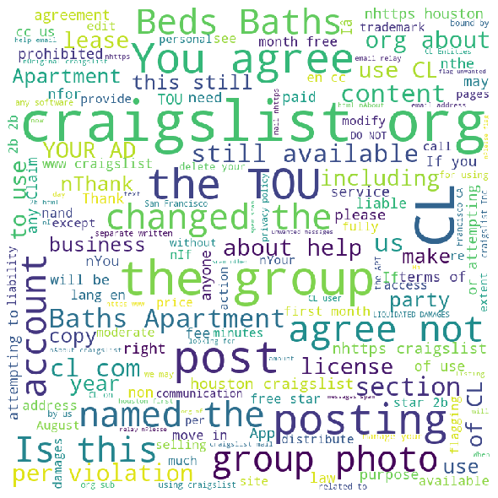

Image : word cloud generated from the conversation with people not visiting the apartment.

The two word clouds produce common keywords like “Apartment”, “lease”, “beds”, “bath”, meaning those are the things a renters are interested when searching for an apartment. *I need to emphasize on the apartment features and lease terms when writing the advertisement.*

# Conclusion

In conclusion, I extracted information from sources like Gmail and Facebook. Cleaned the data and visualized them to find out that Facebook is the advertising platform that is the worthiest of my time and effort. The advertisements are better posted on Saturdays and Craigslist advertisements should be renewed in the morning and Facebook advertisements should be renewed at around noon. People more likely to rent the place will give more positive and affirmative words in the conversation. And information about the apartment (room and bath numbers, etc) and lease are what people are concerned about the most when looking for the apartment.

# Other Remarks

This simple little project not only gave me a chance to use my newly acquired data science skills, but also taught me some other interesting skills, including: *merchandise, competitor and customer analysis, market analysis, drafting an attractive advertisement, and customer service.*

## Analyzing my merchandise (the apartment)

I compared my apartment with other apartments advertising for leasing and came up with a list of strength and weakness of my apartment.

The *strength* of my apartment are:

1. The size (very big and spacy)

2. Big balcony

3. New amenities

4. Neighborhood (quite and safe)

5. School district (good private schools),

6. Community management (well maintained).

The *weakness* of the apartments are:

1. Location: not exactly in the inner loop and can take a while to get to downtown
2. Entertainment: lack entertainment
3. Lease: strict application review

*The strength and weakness lists tell me that my apartment is more ideal for families with children and when I am advertising, I should emphasize on features that would attract families, like safety, space for children to play, etc.*

## Analyzing the customers (people interested in renting)

Understanding the need of the customer is a cliché in the industry yet sometimes hard to fully comprehend. When I first started advertising and got less response than expected, I contacted a few people in rental industry and got many valuable feedbacks. The term of the remainder of the lease is 6 months, which is considered short-term. Usually people looking for a short-term lease would less prefer to buy furniture themselves, but instead much prefer a furnished apartment, which was proven true as my new tenant asked to keep my furniture in the apartment.

## Understanding the Market

Though I would love to claim that my success in finding a replacement tenant is solely due to my hard work on advertising, I cannot deny the rental season might also helped me. The great flux of inquiry for my apartment comes in May Afterall. Renthop.com published some interesting data on rental season. From their monthly Relative Seasonal Rent Difference (%) chart, we can see a change of rent different from negative to positive April to May, indicating a significant change in demand in May.

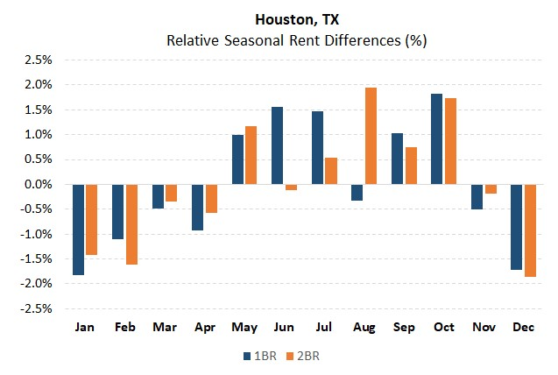

I realized an increase of post by students looking for summer housings starting in May, as well as students looking to sublease their apartment around campus for the summer. It also seems to be an appearance of people relocating for jobs within Houston with the city’s multi-stage opening progress.

## Competitor Analysis

Competitors can also be analyzed. I skimmed through the advertisements posted by others to get inspiration. However, I did not do a systematic analysis of the competitor advertisements considering the outcome might not be worth the effort. Not all advertisements posted are good ones, and there’s no need for me to be like the others. But if I were to perform the analysis, I would extract the keywords in the advertisement titles and the distribution of the keywords’ position. Collect the length of title, message body and number of images.

## Marketing Tactics

Nothing beats having an exciting advertisement.

### Offering attractive price

In order to attract more people, I offered attractive promotions including first-month free and certain monthly pay-back to lower the monthly rental rate. I consider it a wonderful win-win situation as my renter gets a great deal for the apartment and I also save money by getting the apartment off my hand as early as possible.

### Nice looking images

I have no shame in adding filters to my apartment photos. My apartment is a nice-looking apartment, she deserves looking good online as well. Afterall we cannot deny human’s nature to judge the book by its cover.

### Respond promptly

I believe the earlier I respond the inquiries, the better. People asking about the apartment is probably actively browsing and searching at the same time. A delay in response will increase the chance of them finding somewhere else and lose interest in mine.

### Be attentive

When I was communicating with interested renters, I answered all questions to my best ability. I made sure the renters are fully aware of the lease terms and was honest with all their concerns. Though the information did fend off many under-qualified renters, it saved me time in showing the apartment. When people are ready to apply, I helped them in establishing the communication between them and the leasing office and provide as much feedback as I can. There are renters who did not get the apartment because they applied late but thanked me anyway for the help I gave.

Afterall, this is a very interesting experience that gave me a chance to practice non-scientific research skills. Though I do not want to go through the stressful process again, I do appreciate the opportunity to systematically work on something in life.

Humm… maybe I should consider becoming a part-time real-estate agent. What do you say? 😉

# References:

<https://www.renthop.com/studies/national/best-time-of-year-to-rent#:~:text=Rents%20seem%20to%20peak%20in,through%20February%2C%20rents%20drop%20slightly.>

Linkedin Journal: https://www.linkedin.com/posts/zixing-wang_a-journal-on-how-i-marketed-my-apartment-activity-6676948869617655809-O1OL